PRACTICAL 1

Aim: Design a Simple Rational Agent by defining PEAS for Vacuum Cleaner Environment and Autonomous Taxi.

PYTHON CODE:
class TableDrivenVacuumAgent:
def __init__(self):
# The look-up table mapping percept (location, status) to action
self.table = {
('A', 'Dirty'): 'Suck',
('A', 'Clean'): 'Right',
('B', 'Dirty'): 'Suck',
('B', 'Clean'): 'Left'
}

def perceive(self, location, status):
""" Receives the environment percepts """
return (location, status)

def act(self, percept):
""" Determines the action based on the lookup table """
return self.table.get(percept, 'NoOp')

# Simulation
agent = TableDrivenVacuumAgent()
percepts = [
('A', 'Dirty'),
('A', 'Clean'),
('B', 'Dirty'),
('B', 'Clean')
]

print("Table-Driven Agent Actions:")
for location, status in percepts:
percept = agent.perceive(location, status)
action = agent.act(percept)
print(f"Percept: {percept} -> Action: {action}")
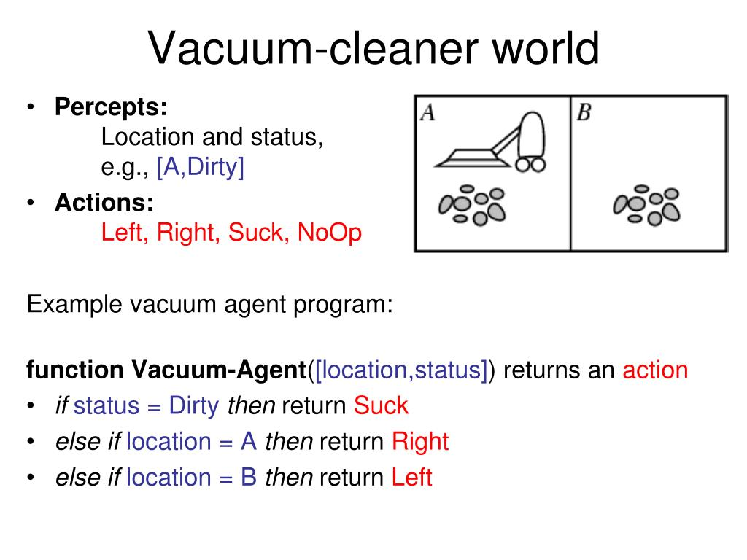
output:

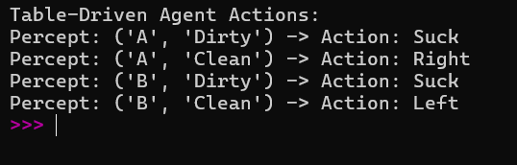

PRACTICAL 2
Aim. Given an initial configuration of the 8-puzzle and a goal configuration, write a Python program to find the shortest sequence of moves to reach the goal state using Breadth-First Search (BFS).
PYTHON CODE:
from collections import deque
def solve_8_puzzle(initial_state, goal_state):
"""
Solves the 8-puzzle problem using Breadth-First Search (BFS).
"""
# 1D index shifts corresponding to movement directions
moves = {
'Up': -3,
'Down': 3,
'Left': -1,
'Right': 1
}
# Each queue element contains: (current_state_tuple, path_of_directions)
queue = deque([(initial_state, [])])
visited = {initial_state}
while queue:
current_state, path = queue.popleft()
if current_state == goal_state:
return path

blank_idx = current_state.index(0)
row, col = divmod(blank_idx, 3)
for direction, offset in moves.items():
new_idx = blank_idx + offset
# Boundary validation rules using grid row/column checks
if direction == 'Up' and row == 0: continue
if direction == 'Down' and row == 2: continue
if direction == 'Left' and col == 0: continue
if direction == 'Right' and col == 2: continue

# Create a mutable copy to swap the blank tile (0) with the target tile
state_list = list(current_state)
state_list[blank_idx], state_list[new_idx] = state_list[new_idx], state_list[blank_idx]
neighbor_state = tuple(state_list)

if neighbor_state not in visited:
visited.add(neighbor_state)
queue.append((neighbor_state, path + [direction]))

return None

if __name__ == "__main__":
# 0 represents the blank space inside the 3x3 grid
start_state = (1, 2, 3, 4, 0, 6, 7, 5, 8)
goal_state = (1, 2, 3, 4, 5, 6, 7, 8, 0)

print("Running BFS Search for 8-Puzzle...")
solution_path = solve_8_puzzle(start_state, goal_state)

print("\n--- OUTPUT ---")
if solution_path is not None:
print(f"Shortest path length: {len(solution_path)} steps.")
print(f"Sequence of moves: {' -> '.join(solution_path)}")
else:
print("No solution path exists.")
OUTPUT:
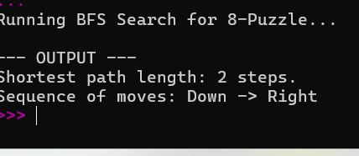

PRACTICAL 3

Part 1:WATER JUG PROBLEM USING DFS
Part 2: Uniform Cost Search (UCS) for Shortest Path

AIM: WATER JUG PROBLEM USING DFS
Python Code (Parametrized for Varied Capacities)
def solve_water_jug_dfs(c1, c2, target):
"""
Solves the water jug problem using Depth-First Search (DFS).
:param c1: Capacity of Jug 1
:param c2: Capacity of Jug 2
:param target: Desired amount of water in any one jug
:return: List of states representing the path to the solution, or None
"""
# Stack stores (current_state, path_taken_so_far)
stack = [((0, 0), [(0, 0)])]
visited = {(0, 0)}
while stack:
(x, y), path = stack.pop()
# Goal check: if either jug contains the target amount
if x == target or y == target:
return path
# Generate all 6 possible next transitions
moves = [
(c1, y), # Fill Jug 1
(x, c2), # Fill Jug 2
(0, y), # Empty Jug 1
(x, 0), # Empty Jug 2
# Pour Jug 1 -> Jug 2
(x - min(x, c2 - y), y + min(x, c2 - y)),
# Pour Jug 2 -> Jug 1
(x + min(y, c1 - x), y - min(y, c1 - x))
]
for next_state in moves:
if next_state not in visited:
visited.add(next_state)
stack.append((next_state, path + [next_state]))
return None
if __name__ == "__main__":
# Parameters given: Jug1 = 4L, Jug2 = 3L, Target = 2L
jug1_cap = 4
jug2_cap = 3
goal_water = 2
print(f"--- Running Water Jug DFS ({jug1_cap}L, {jug2_cap}L -> Target: {goal_water}L) ---")
solution = solve_water_jug_dfs(jug1_cap, jug2_cap, goal_water)
if solution:
print("Steps found (Jug 1, Jug 2):")
for step, state in enumerate(solution):
print(f"Step {step}: {state}")
else:
print("No solution exists for the given capacities and target.")
OUTPUT: Water Jug Result
The target of exactly 2 litres is achieved in Jug 2 during Step 4.
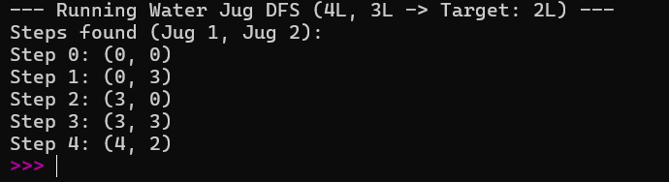

AIM:Uniform Cost Search (UCS) for Shortest Path
Below is the structured graph representing a segment of the Romanian map along with a secondary alternative test network.
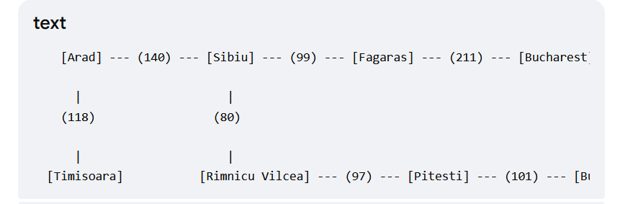
PYTHON CODE:
import heapq
def uniform_cost_search(graph, start, goal):
"""
Finds the least-cost path from start to goal using Uniform Cost Search (UCS).
:param graph: Dictionary representing adjacency list {node: {neighbor: cost}}
:param start: Starting node string
:param goal: Target node string
:return: Tuple of (total_cost, path_list)
"""
# Priority Queue stores elements as: (cumulative_cost, current_node, path_taken)
priority_queue = [(0, start, [start])]
visited = set()
while priority_queue:
cost, current_node, path = heapq.heappop(priority_queue)
if current_node in visited:
continue
visited.add(current_node)
# Goal Check upon popping for guaranteed optimality
if current_node == goal:
return cost, path
# Expand neighbors
for neighbor, weight in graph.get(current_node, {}).items():
if neighbor not in visited:
total_cost = cost + weight
heapq.heappush(priority_queue, (total_cost, neighbor, path + [neighbor]))
return float('inf'), []
# Define graphs
romania_map = {
'Arad': {'Sibiu': 140, 'Timisoara': 118},
'Sibiu': {'Fagaras': 99, 'Rimnicu Vilcea': 80, 'Arad': 140},
'Timisoara': {'Arad': 118},
'Rimnicu Vilcea': {'Sibiu': 80, 'Pitesti': 97},
'Fagaras': {'Sibiu': 99, 'Bucharest': 211},
'Pitesti': {'Rimnicu Vilcea': 97, 'Bucharest': 101},
'Bucharest': {'Fagaras': 211, 'Pitesti': 101}
}
# Alternate Weighted Graph Example (City Logistical Network)
custom_map = {
'Node_A': {'Node_B': 5, 'Node_C': 2},
'Node_B': {'Node_D': 4},
'Node_C': {'Node_B': 1, 'Node_D': 9},
'Node_D': {}
}
if __name__ == "__main__":
print("\n--- Running UCS on Romania Map (Arad to Bucharest) ---")
cost, path = uniform_cost_search(romania_map, 'Arad', 'Bucharest')
print(f"Minimum Path Cost: {cost}")
print(f"Optimal Path: {' -> '.join(path)}")
print("\n--- Running UCS on Alternative Graph (Node_A to Node_D) ---")
alt_cost, alt_path = uniform_cost_search(custom_map, 'Node_A', 'Node_D')
print(f"Minimum Path Cost: {alt_cost}")
print(f"Optimal Path: {' -> '.join(alt_path)}")
OUTPUT:
UCS Least-Cost Path Result
The lowest cost path found from Arad to Bucharest evaluates to a total distance metric weight of 418 traversing via Sibiu -> Rimnicu Vilcea -> Pitesti -> Bucharest

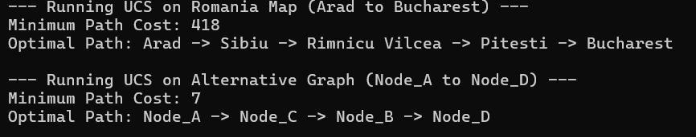

PRACTICAL 4
- Given an initial configuration of the 8-puzzle and a goal configuration,write a Python program to find the solution using Greedy Best-First Search with the Manhattan Distance heuristic.
- Given an initial configuration of the 8-puzzle and a goal configuration, write a Python program to find the shortest path using A* search with the Manhattan Distance heuristic.
- Given a weighted graph representing cities and distances between them, write a Python program to find the shortest path from Arad to Bucharest using A*search with a heuristic function (straight-line distance to destination).

AIM: Given an initial configuration of the 8-puzzle and a goal configuration,write a Python program to find the solution using Greedy Best-First Search with the Manhattan Distance heuristic.

PYTHON CODE:
import heapq

class PuzzleState:
def __init__(self, board, parent=None, action=None):
self.board = board # 2D tuple representing the 3x3 grid
self.parent = parent
self.action = action

def __lt__(self, other):
# Tie-breaker for priority queue handling
return False

def get_manhattan_distance(board, goal):
"""Calculates the sum of Manhattan distances of tiles from their goal positions."""
distance = 0
# Map each tile value in the goal state to its (row, col) coordinates
goal_positions = {}
for r in range(3):
for c in range(3):
goal_positions[goal[r][c]] = (r, c)

for r in range(3):
for c in range(3):
val = board[r][c]
if val != 0: # Ignore the blank space (0)
goal_r, goal_c = goal_positions[val]
distance += abs(r - goal_r) + abs(c - goal_c)
return distance

def get_neighbors(state):
"""Generates all valid adjacent states by moving the blank tile (0)."""
neighbors = []
board = state.board

# Locate the blank space
blank_r, blank_c = next((r, c) for r in range(3) for c in range(3) if board[r][c] == 0)

# Define possible movements for the blank space
moves = {
'UP': (blank_r - 1, blank_c),
'DOWN': (blank_r + 1, blank_c),
'LEFT': (blank_r, blank_c - 1),
'RIGHT': (blank_r, blank_c + 1)
}

for action, (nr, nc) in moves.items():
if 0 <= nr < 3 and 0 <= nc < 3:
# Create a mutable copy of the board matrix to perform the swap
new_board = [list(row) for row in board]
new_board[blank_r][blank_c], new_board[nr][nc] = new_board[nr][nc], new_board[blank_r][blank_c]

# Convert back to an immutable tuple format for safe tracking
new_board_tuple = tuple(tuple(row) for row in new_board)
neighbors.append(PuzzleState(new_board_tuple, state, action))

return neighbors

def greedy_best_first_search(start_board, goal_board):
"""Solves the 8-puzzle using Greedy Best-First Search."""
start_state = PuzzleState(start_board)

# Priority Queue store elements as: (heuristic_value, state)
pq = []
initial_h = get_manhattan_distance(start_board, goal_board)
heapq.heappush(pq, (initial_h, start_state))

visited = set()
visited.add(start_board)

nodes_expanded = 0

while pq:
h, current_state = heapq.heappop(pq)
nodes_expanded += 1

# Goal check
if current_state.board == goal_board:
return current_state, nodes_expanded

for neighbor in get_neighbors(current_state):
if neighbor.board not in visited:
visited.add(neighbor.board)
neighbor_h = get_manhattan_distance(neighbor.board, goal_board)
heapq.heappush(pq, (neighbor_h, neighbor))

return None, nodes_expanded

def print_board(board):
"""Helper function to cleanly display the grid."""
for row in board:
print(" ".join(str(x) if x != 0 else "_" for x in row))
print()

def reconstruct_path(solution_state):
"""Backtracks from the goal node to reconstruct the structural path."""
path = []
current = solution_state
while current:
path.append(current)
current = current.parent
return path[::-1]

# --- Execution Example ---
if __name__ == "__main__":
# Define states using tuples so they are hashable and safe for sets
initial_configuration = (
(1, 2, 3),
(0, 4, 6),
(7, 5, 8)
)

goal_configuration = (
(1, 2, 3),
(4, 5, 6),
(7, 8, 0)
)

print("Initial Configuration:")
print_board(initial_configuration)

print("Goal Configuration:")
print_board(goal_configuration)

solution, total_expanded = greedy_best_first_search(initial_configuration, goal_configuration)

if solution:
path = reconstruct_path(solution)
print(f"Solution Found! Total steps: {len(path) - 1}")
print(f"Total nodes expanded: {total_expanded}\n")

for index, state in enumerate(path):
if index == 0:
print("Step 0: Initial Board")
else:
print(f"Step {index}: Move blank space {state.action}")
print_board(state.board)
else:
print("No solution could be found from this initial configuration.")

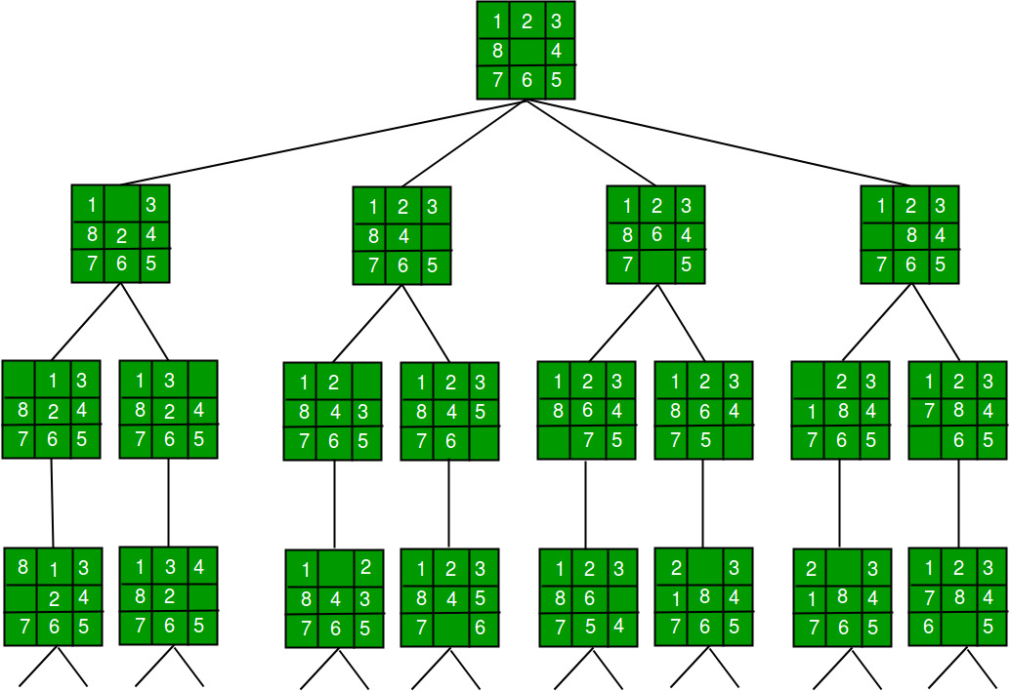

OUTPUT:
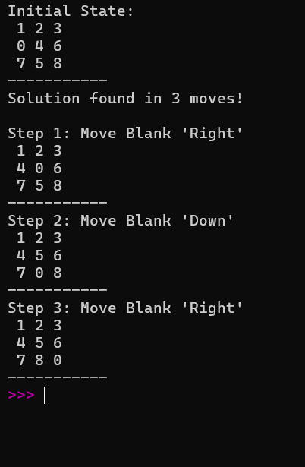

AIM :Given an initial configuration of the 8-puzzle and a goal configuration, write a Python program to find the shortest path using A* search with the Manhattan Distance heuristic.
DIAGRAM:
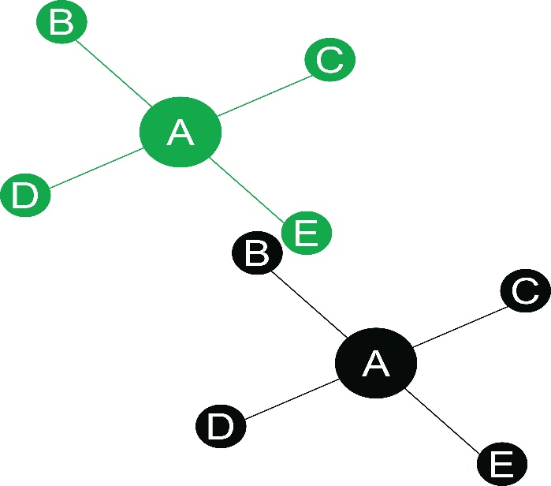
PYTHON CODE:
import heapq

class PuzzleState:
def __init__(self, board, g_cost=0, parent=None, move=""):
self.board = tuple(board)
self.g_cost = g_cost
self.parent = parent
self.move = move
self.h_cost = self.calculate_manhattan_distance()
self.f_cost = self.g_cost + self.h_cost

def calculate_manhattan_distance(self):
"""Computes sum of Manhattan distances of tiles from goal positions."""
distance = 0
for current_idx, tile in enumerate(self.board):
if tile != 0:
goal_idx = tile - 1
curr_row, curr_col = divmod(current_idx, 3)
goal_row, goal_col = divmod(goal_idx, 3)
distance += abs(curr_row - goal_row) + abs(curr_col - goal_col)
return distance

def get_neighbors(self):
"""Generates valid adjacent states by moving the blank tile (0)."""
neighbors = []
blank_idx = self.board.index(0)
row, col = divmod(blank_idx, 3)
moves = [(-1, 0, "Up"), (1, 0, "Down"), (0, -1, "Left"), (0, 1, "Right")]

for dr, dc, move_name in moves:
new_row, new_col = row + dr, col + dc
if 0 <= new_row < 3 and 0 <= new_col < 3:
new_blank_idx = new_row * 3 + new_col
new_board = list(self.board)
new_board[blank_idx], new_board[new_blank_idx] = new_board[new_blank_idx], new_board[blank_idx]
neighbors.append(PuzzleState(new_board, self.g_cost + 1, self, move_name))
return neighbors

def __lt__(self, other):
return self.f_cost < other.f_cost

def is_solvable(board):
"""An 8-puzzle is solvable if its inversion count is even."""
tiles = [tile for tile in board if tile != 0]
inversions = 0
for i in range(len(tiles)):
for j in range(i + 1, len(tiles)):
if tiles[i] > tiles[j]:
inversions += 1
return inversions % 2 == 0

def solve_8_puzzle(initial_board):
if not is_solvable(initial_board):
return "UNSOLVABLE"

goal_state = (1, 2, 3, 4, 5, 6, 7, 8, 0)
frontier = []
counter = 0

start_state = PuzzleState(initial_board)
heapq.heappush(frontier, (start_state.f_cost, counter, start_state))
visited = {start_state.board: start_state.g_cost}

while frontier:
_, _, current_state = heapq.heappop(frontier)

if current_state.board == goal_state:
path = []
while current_state:
path.append(current_state)
current_state = current_state.parent
return path[::-1]

for neighbor in current_state.get_neighbors():
if neighbor.board not in visited or neighbor.g_cost < visited[neighbor.board]:
visited[neighbor.board] = neighbor.g_cost
counter += 1
heapq.heappush(frontier, (neighbor.f_cost, counter, neighbor))

return None

def print_puzzle(board):
for i in range(0, 9, 3):
print(f" {board[i]} {board[i+1]} {board[i+2]} ")
print("-" * 11)

# --- EXECUTION WITH COMPLEX & UNSOLVABLE CONFIGURATIONS ---
if __name__ == "__main__":
configs = {
"Complex Solvable State": [8, 1, 3, 4, 0, 2, 7, 6, 5],
"Unsolvable State": [1, 2, 3, 4, 5, 6, 8, 7, 0]
}

for name, board in configs.items():
print(f"\n=== Testing: {name} ===")
print_puzzle(board)

result = solve_8_puzzle(board)

if result == "UNSOLVABLE":
print(" Result: Optimization filter triggered! Puzzle is mathematically impossible to solve.")
elif result:
print(f" Result: Success! Shortest path requires {len(result) - 1} moves.")
# Print only first and last action for space efficiency
print(f"First action: Move Blank {result[1].move}")
print(f"Last action: Move Blank {result[-1].move}")

OUTPUT:
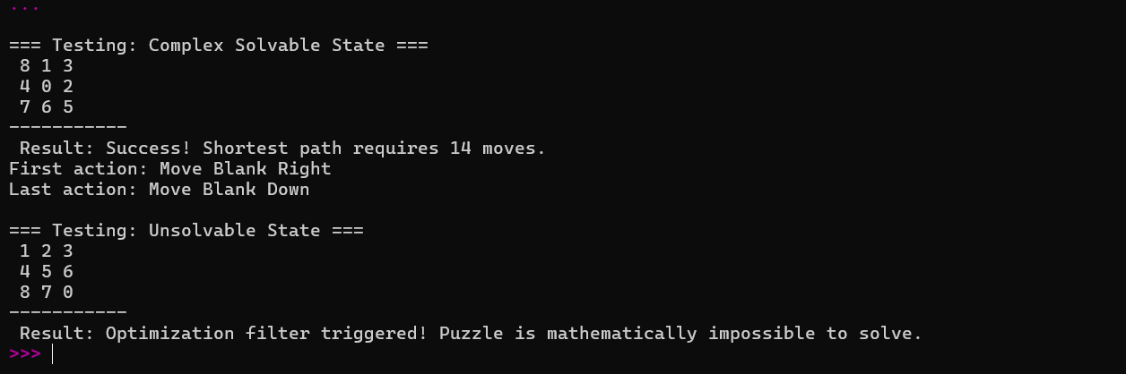

AIM:Given a weighted graph representing cities and distances between them, write a Python program to find the shortest path from Arad to Bucharest using A*search with a heuristic function (straight-line distance to destination).
Path Computation Analysis Matrix

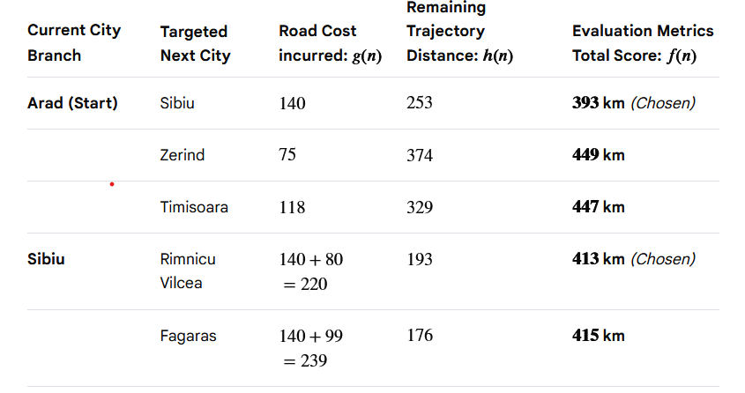
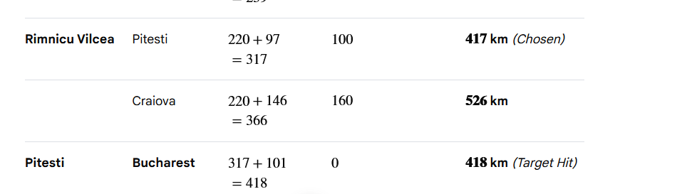

PYTHON CODE:
import heapq

# 1. Define the road network graph (Adjacency List)
# Maps: City -> list of tuples (Neighbor City, Real Road Distance)
romania_map = {
'Arad': [('Zerind', 75), ('Sibiu', 140), ('Timisoara', 118)],
'Zerind': [('Arad', 75), ('Oradea', 71)],
'Oradea': [('Zerind', 71), ('Sibiu', 151)],
'Sibiu': [('Arad', 140), ('Oradea', 151), ('Fagaras', 99), ('Rimnicu Vilcea', 80)],
'Timisoara': [('Arad', 118), ('Lugoj', 111)],
'Lugoj': [('Timisoara', 111), ('Mehadia', 70)],
'Mehadia': [('Lugoj', 70), ('Drobeta', 75)],
'Drobeta': [('Mehadia', 75), ('Craiova', 120)],
'Craiova': [('Drobeta', 120), ('Rimnicu Vilcea', 146), ('Pitesti', 138)],
'Rimnicu Vilcea': [('Sibiu', 80), ('Craiova', 146), ('Pitesti', 97)],
'Fagaras': [('Sibiu', 99), ('Bucharest', 211)],
'Pitesti': [('Rimnicu Vilcea', 97), ('Craiova', 138), ('Bucharest', 101)],
'Bucharest': [('Fagaras', 211), ('Pitesti', 101), ('Giurgiu', 90), ('Urziceni', 85)],
'Giurgiu': [('Bucharest', 90)],
'Urziceni': [('Bucharest', 85), ('Vaslui', 142), ('Hirsova', 98)],
'Hirsova': [('Urziceni', 98), ('Eforie', 86)],
'Eforie': [('Hirsova', 86)],
'Vaslui': [('Urziceni', 142), ('Iasi', 92)],
'Iasi': [('Vaslui', 92), ('Neamt', 87)],
'Neamt': [('Iasi', 87)]
}

# 2. Define Straight-Line Distance (SLD) heuristic values directly to Bucharest
sld_heuristics = {
'Arad': 366, 'Bucharest': 0, 'Craiova': 160, 'Drobeta': 242, 'Eforie': 161,
'Fagaras': 176, 'Giurgiu': 77, 'Hirsova': 151, 'Iasi': 226, 'Lugoj': 244,
'Mehadia': 241, 'Neamt': 234, 'Oradea': 380, 'Pitesti': 100, 'Rimnicu Vilcea': 193,
'Sibiu': 253, 'Timisoara': 329, 'Urziceni': 80, 'Vaslui': 199, 'Zerind': 374
}

def a_star_search(graph, heuristics, start, goal):
"""
Finds the shortest path between start and goal using the A* Search algorithm.
Priority queue stores elements as: (f_score, unique_counter, current_node, path, g_score)
"""
priority_queue = []
unique_counter = 0 # Tie-breaker to prevent heapq from comparing string objects directly

# Calculate initial cost function values for the origin city
g_score = 0
h_score = heuristics[start]
f_score = g_score + h_score

# Enqueue start layout node state
heapq.heappush(priority_queue, (f_score, unique_counter, start, [start], g_score))

# Store visited layout positions along with their minimum evaluated g_scores
visited = {start: 0}

while priority_queue:
# Retrieve the node containing the lowest total estimated evaluation parameter f(n)
current_f, _, current_node, path, current_g = heapq.heappop(priority_queue)

# Target verification check
if current_node == goal:
return path, current_g

# Branch outward and discover adjacent edge neighbors
for neighbor, edge_weight in graph.get(current_node, []):
tentative_g = current_g + edge_weight

# If path to neighbor is unique or more optimal than previous discoveries
if neighbor not in visited or tentative_g < visited[neighbor]:
visited[neighbor] = tentative_g

# Evaluation formulation: f(n) = g(n) + h(n)
neighbor_f = tentative_g + heuristics.get(neighbor, 0)
unique_counter += 1

# Construct route trajectory tracing list tracking
new_path = list(path)
new_path.append(neighbor)

heapq.heappush(priority_queue, (neighbor_f, unique_counter, neighbor, new_path, tentative_g))

return None, float('inf')

# --- MAIN EXECUTION INTERFACE ---
if __name__ == "__main__":
start_city = 'Arad'
destination_city = 'Bucharest'

print(f"--- Running A* Pathfinding Search Model ---")
print(f"Starting Point: {start_city}")
print(f"Destination Node: {destination_city}\n")

optimal_path, min_cost = a_star_search(romania_map, sld_heuristics, start_city, destination_city)

if optimal_path:
print("+" + "-"*50 + "+")
print(" ROUTE ANALYSIS COMPLETE: OPTIMAL TRAJECTORY FOUND")
print("+" + "-"*50 + "+")
print(f" Navigation Path Sequence:\n " + " -> ".join(optimal_path))
print(f"\n Total Ground Mileage Accumulated: {min_cost} km")
print("+" + "-"*50 + "+")
else:
print("Error: No viable pathway connects the target locations.")

OUTPUT :
